EARTH, SPIRIT, ACTION
a workshop with John Seed
John Seeds’ work has us experience ourselves as part of the living Earth, rather than separate
from it. The process he facilitates is aimed at enabling us to find our own role in powerfully protecting the planet.

Arnie Naess, Emeritus Professor of Philosophy of Oslo University who coined the term “deep
ecology”, said that “ecological ideas are not enough”; we need “ecological identity, ecological self”. Naess says that this is brought about through community therapies, “healing our relations to a widest community, that of all living beings”.

In this workshop we explore a series of ceremonies and rituals synchronous with those used by Indigenous peoples throughout time. Through experiential deep ecology exercises, despair work, music and poetry we remember our interconnectedness.
The Experience of Deep Ecology
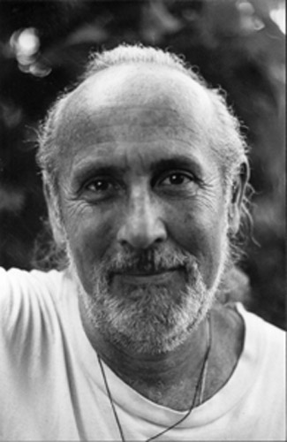
.
Friday 29 February to Sunday 02 March
Douglas Scrub Residential
Costs include full vegan catering and accommodation
$150 unwaged thru to $250 full-waged
proceeds to benefit the reforestation of the sacred mountain Arunachala in Southern India

ONLY 40 PLACES AVAILABLE BOOK EARLY

carbon neutral bring instruments fragrance free

for bookings and more information phone chris lambert 0400 290 032
this workshop is a WECAN (Willunga Environs Climate Action Network) initiative

